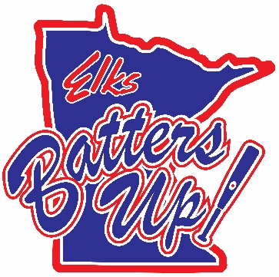
Photography and Video Release Form
I grant permission to employees and agents of the <local lodge name> the right to obtain and publish photography and/or video in which I am featured.
I agree that the <local lodge name> may use such photographs or video of me with or without my name and for any lawful purpose, including for example such purposes as publicity, illustration, advertising, social media and web content.
I agree that the <local lodge name> owns all rights related to the photography and/or video.
I waive any right to inspect, approve, or be compensated for the photograph and/or video.
I release the <local lodge name> and its employees and agents from any claims, damages, or liability in connection with obtaining or using photography and/or video.
I have read and understand the above:
Date | Printed Name | Telephone or email | Signature Parent

