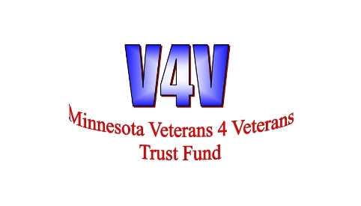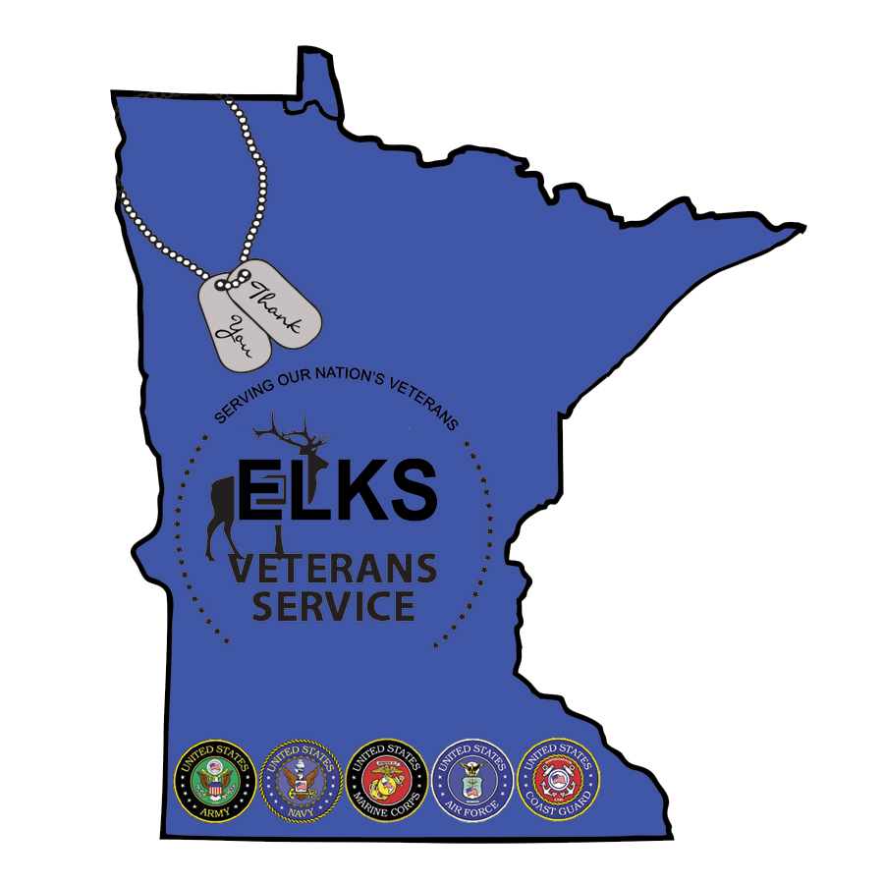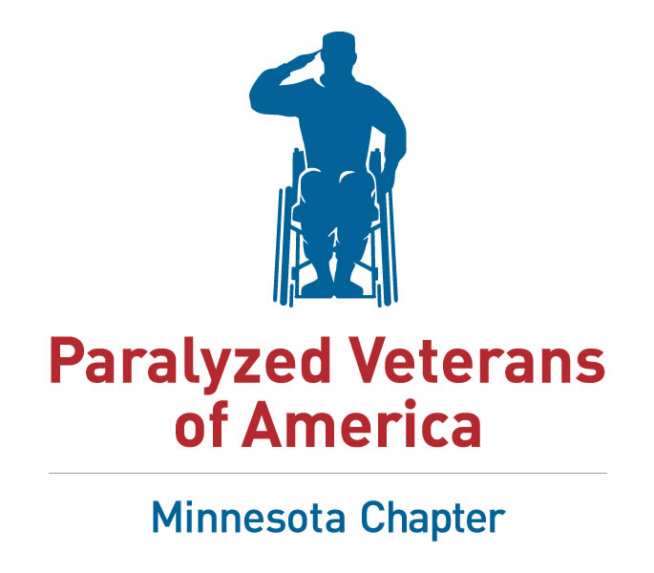
“Application Form “Trolling for the Troops 2019”

We believe that all Veterans and any Soldier of any branch and service, who have served our country through the years deserve a day on the lake. If this describes you, here’s your opportunity to get a chance to fish with some of the best anglers in the Midwest! Well known professional fishermen and others will guide a Veteran and a Soldier for a day on Mille Lacs Lake or the Mississippi River! This will be a fun, exciting, day of fishing in boats that make heads turn. Prizes will be awarded to the most successful anglers!

Details: Trolling for the Troops
Date: Thursday/Friday, June 6 - June 8, 2019
Headquarters: Camp Ripley, MN
Fishing Locations: Mille Lacs Lake and Mississippi River
To apply: Email: mn.service.orgs@gmail.com or Camp Ripley Veterans Outdoor Programs FaceBook page, print the application form and send to MN Veteran Outdoor Programs, PO Box 953, St. Cloud, MN 56302, Applications are due by April 29, 2019 ! Lodging and meals provided by Sponsors for the annual Trolling for the Troops program

Name ____________________________________________Rank:________________
Address ________________________________________________________________
City ________________________________ State _____ Zip Code ________________
Home # (_____) _______________________ Cell # ( ) ______________________
Email __________________________________ D.O.B. _______________________________
Emergency Contact _____________________________ Phone # _________________________
Relationship to Emergency Contact: __________________________
Briefly describe (IF) physical disabilities: ________________________________________________
Do you require the use of a WHEELCHAIR for independence: Yes_______ No _________
Please circle items used: WALKER CANE CRUTCHES other________________________________
Allergies (be specific) ___________________________________________________________________
Shirt Size, Small______Medium______Large______XLarge_X_____XXLarge_______________________

For specific questions regarding the event, please contact: Dennis Erie, MN Veterans Outdoor Coordinator: 320-380-4569 or email mn.service.orgs@gmail.com. Information regarding lodging and logistics will be mailed to the selected applicants. Lodging and meals will be provided by event sponsors.
By signing this application you hereby agree /allow for voice and photo release to promote the 2019 T4T event. Signature: _________________

Agenda for June 6 – June 8, 2019
JUNE 6
- 1500 - 1645 Registration -Team Meet and Greet @ Camp Ripley
- 1700 - 2100 Group photo, evening dinner, door prizes
JUNE 7
- 0630-1530 Fishing
- 1700-1900 Meal and awards
Please go out and like us on Face Book at www.facebook.com/CampRipleyVeteransOutdoorPrograms
Additional info at: www.mnlegion.org , www.davmn.org , www.mnvfw.org
Please circle status: SOLDIER VETERAN
Applications are due by April 29, 2019

