Elks Kids &  Grandkids Week  Session 1: July 24 – July 29, 2022  Session 2: July 31 – August 5, 2022  Send Your Child to Camp!  Spots Are Limited-Sign Up Now!  - Two sessions are set aside for children and grandchildren of Elks members and their friends.  - Co-ed camp for kids 9-13 years old  - North woods setting - 270+ acres around Pelican Lake in Nisswa, MN  - Cost is $175 for children or grand-children of Elks members  - Your child can bring a friend to share the camp experience – cost for Non Elks children is $225  - Spots are limited and granted on a first come first serve basis. Registration is done ONLINE on the Youth Camp web site at: http://www.mnelksyouthcamp.org  Under Camp Sessions / Elks Kids Week.  - Registration opens up on April 1, 2022.  - You are required to provide transportation to and from camp. | 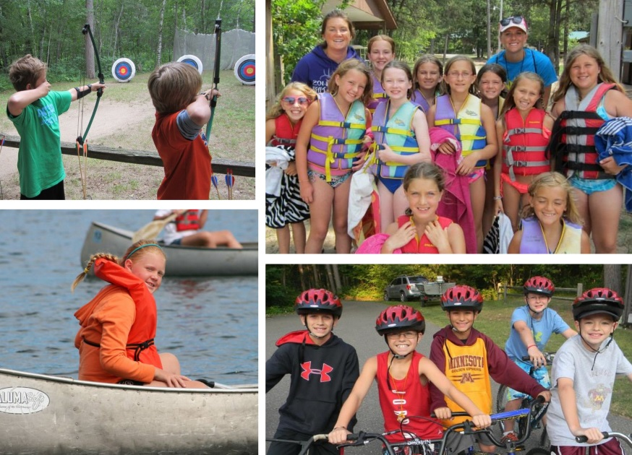  Some of the great activities at camp:  - Archery - Arts & Crafts - Miniature Golf - Biking - Kayaking - Swimming - Volleyball - Basketball - Fishing - Theater - Playground - Softball - Golf Driving Range - Karaoke - Climbing Wall - Canoeing

Get more info on the camp and register at http://www.mnelksyouthcamp.org

