A Moment Lasts Only A Second  But The Memory Lives On Forever  Help your child make great memories at the Minnesota Elks Youth Camp.  - Summer youth camp for deserving youth sponsored by Elks lodges throughout Minnesota  - Free co-ed camp for kids 9-13 years old  - North woods setting - 270+ acres on and around Pelican Lake in Nisswa, MN with sandy beaches and fun activities is ideal for teaching youth about the great outdoors  - Elks pay all necessary camper fees as well as provide free transportation to and from the camp  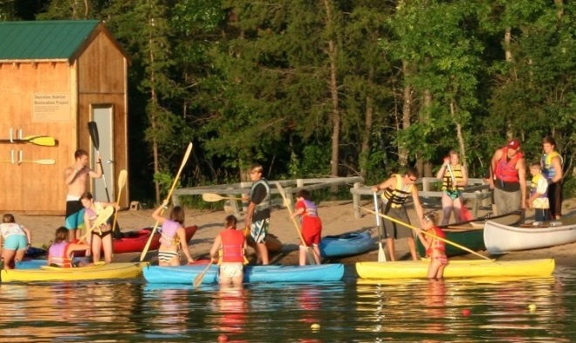 | 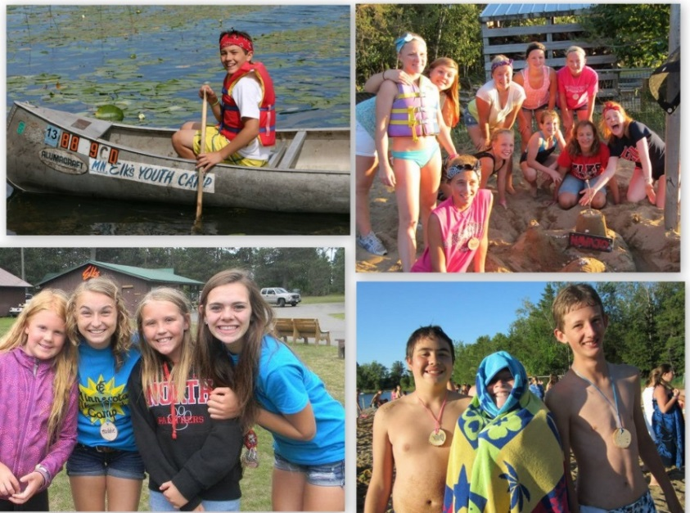  Some of the great activities at camp:  - Archery - Arts & Crafts - Miniature Golf - Biking - Kayaking - Swimming - Volleyball - Basketball - Fishing - Theater - Playground - Softball - Driving Range - Karaoke - Climbing Wall - Canoeing
Space is limited for our free camping sessions. Contact your local Elks lodge for more info.
Contact your local Elks Lodge to find out how to send your child to camp

Get more information on the camp at http://www.mnelksyouthcamp.org

