A Moment Lasts Only A Second  But The Memory Lives On Forever  Help your child make great memories at the Minnesota Elks Youth Camp.  - Summer youth camp for deserving youth sponsored by Elks lodges throughout Minnesota  - Free co-ed camp for kids 9-13 years old who might not otherwise have the opportunity to attend summer camp  - North woods setting - 270+ acres on and around Pelican Lake in Nisswa, MN with sandy beaches and fun activities is ideal for teaching youth about the great outdoors  - Elks pay all necessary camper fees as well as provide free transportation to and from the camp  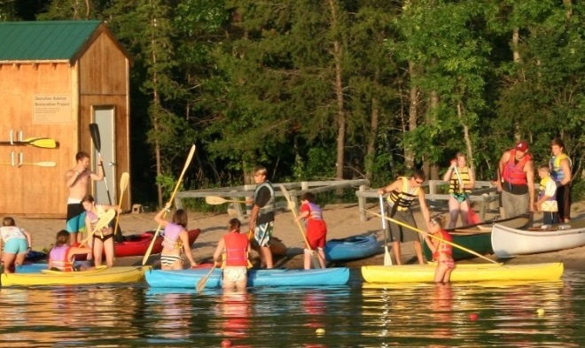 | 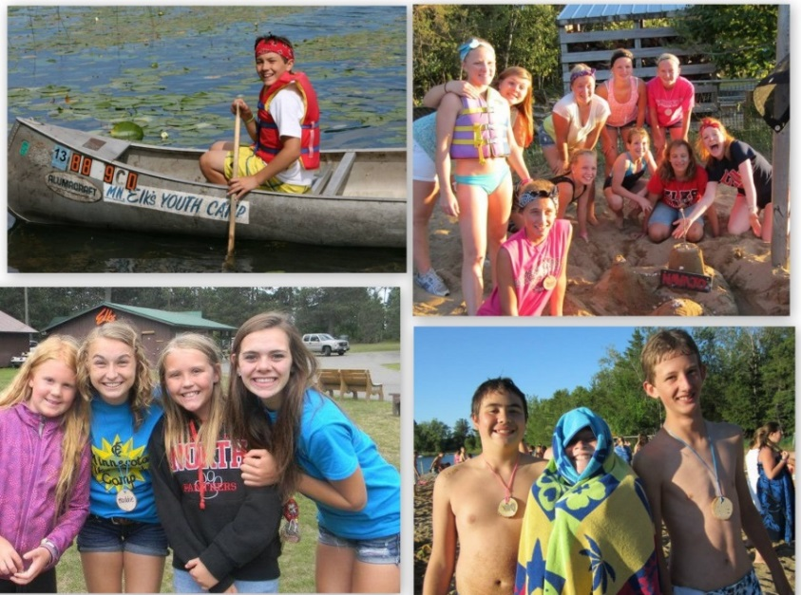  Some of the great activities at camp:  - Archery - Arts & Crafts - Miniature Golf - Biking - Kayaking - Swimming - Volleyball - Basketball - Fishing - Theater - Playground - Softball - Driving Range - Karaoke - Climbing Wall - Canoeing
Space is limited for our free camping sessions. Contact your local Elks lodge for more info.
Help a deserving youth enjoy a week long north woods experience

Get more information on the camp at http://www.mnelksyouthcamp.org

