Troops Week  Session 1: July 17-23, 2016  Our Troops Week program is designed to show support and appreciation for our troops and their families. We try to focus on kids of actively deployed parents but all military families are welcome to sign up.  - Summer youth camp sponsored by Elks lodges throughout Minnesota  - Free co-ed camp for kids 9-13 years old  - North woods setting - 270+ acres on and around Pelican Lake in Nisswa, MN | 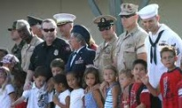  Some of the great activities at camp:  - Archery - Arts & Crafts - Miniature Golf - Biking - Kayaking - Swimming - Volleyball - Basketball - Fishing - Theater - Playground - Softball - Golf Driving Range - Karaoke - Climbing Wall - Canoeing  Space is limited for our Troops Week camping sessions.  It is First Come First Serve!
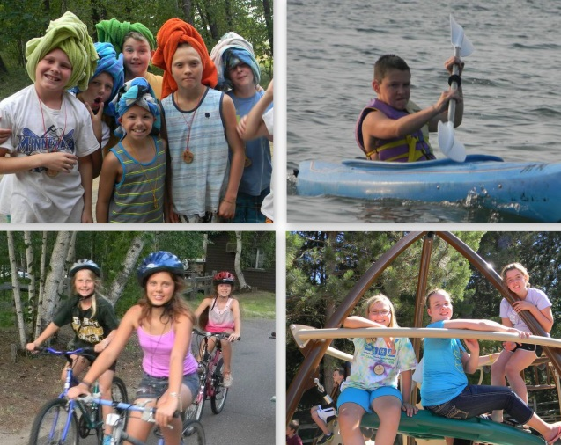
Contact Troops Week Organizer Tom Kramin at 320-292-5996 or via email vets@mnelks.org to find out how to send your child to camp

Get more info on the camp and how to register at http://www.mnelksyouthcamp.org

